Declaration of Local Travel Expenses

I have incurred expenditure of about Rs. 1200 towards travel expenses for auto during night patrolling of Banswara Nagar Parishad on 26-09-17 to 30-09-17 from ward 1 to 45.

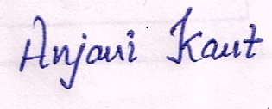

Signature